Calibration information

Comparison of Observed and Simulated Results
The charts below show comparisons between the measured flow data (black dotted lines) with the flow values simulated using WAM (solid red line) over the 10-year calibration period (Figure 18). Each chart includes an upper pane showing rainfall over the same period (higher rainfall values increase downward), a middle pane showing the observed and simulated flow time series, and a lower pane showing accumulated volume of the observed and simulated data. The goodness of fit (GOF) values at the stations along the main stem of the Peace River show good to excellent fits over the calibration period with NSE values ranging from 0.77 to 0.9 (Table 12). Additionally, statistics include the root-mean-square error (RMSE), percent bias (% bias), the Kling-Gupta Efficiency (KGE), a non-parametric version of the Kling-Gupta Efficiency (KGE non-par), Pearson Correlation Coefficient (Pears. Corr.), and the Spearman Rank Coefficient (Spear. Rank). These were calculated using the R package hydroGOF (Zambrano-Bigiarini, 2014). The sequence of charts shown below are a set of results from north to south along the main stem of the Peace River including gages at Bartow, Clear Springs, Fort Meade, Zolfo Springs, and Arcadia. Results at the 19 gage locations shown in Figure 17 for the 24-year period from 2000 – 2023 are shown in the Appendix (Section 10.7.1).
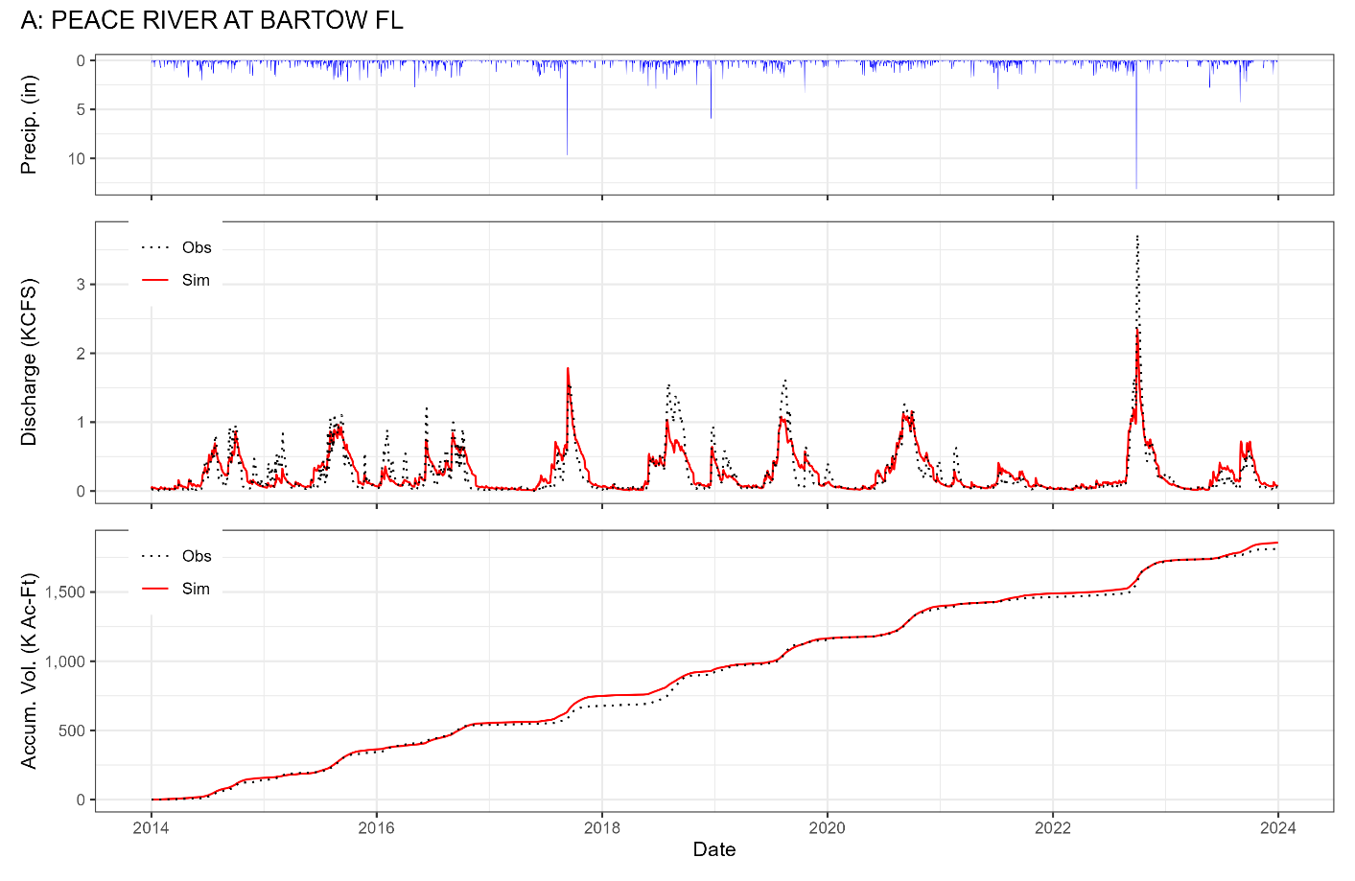
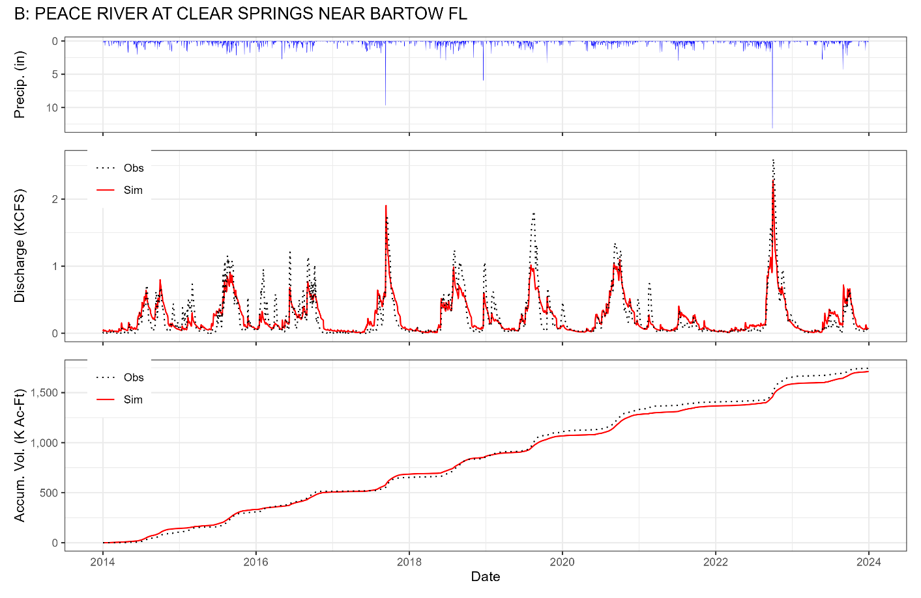
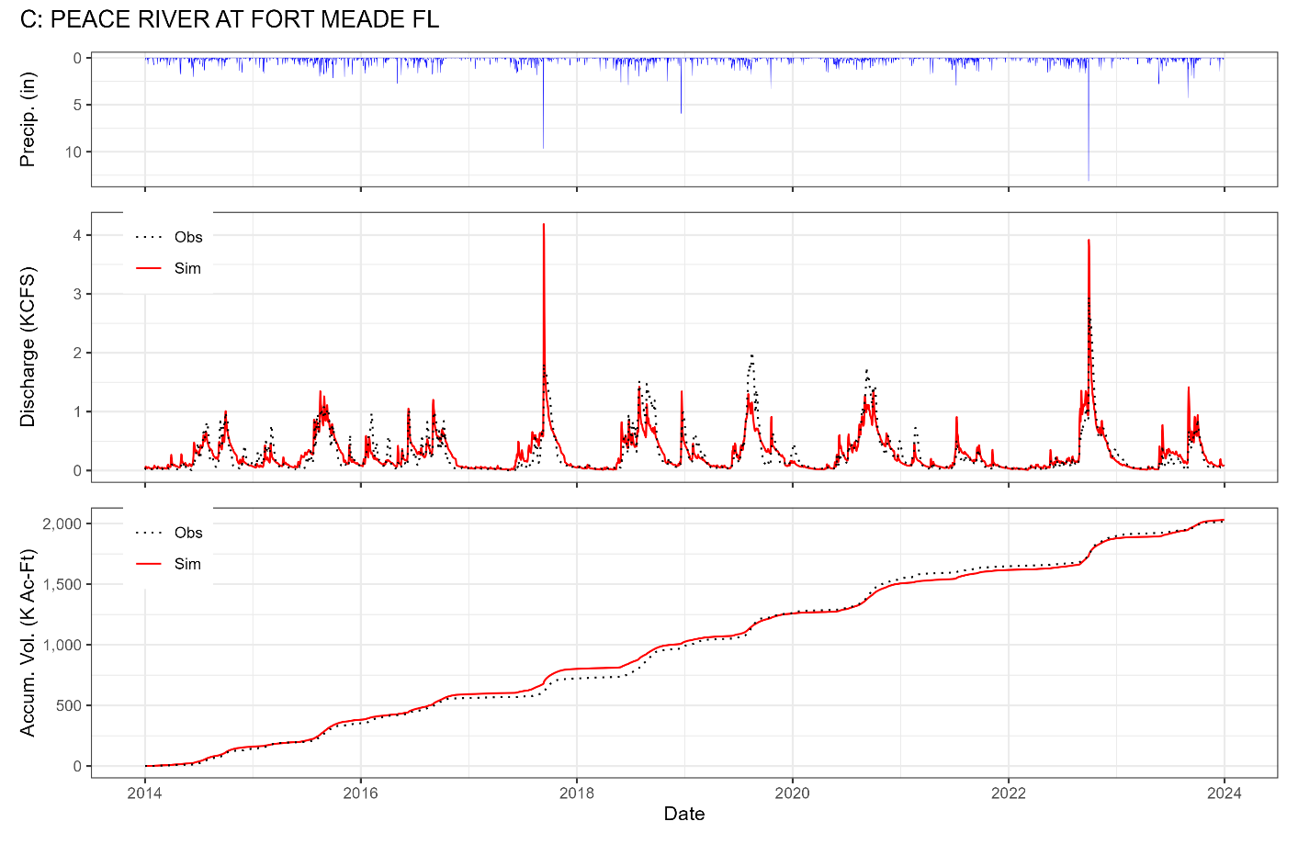

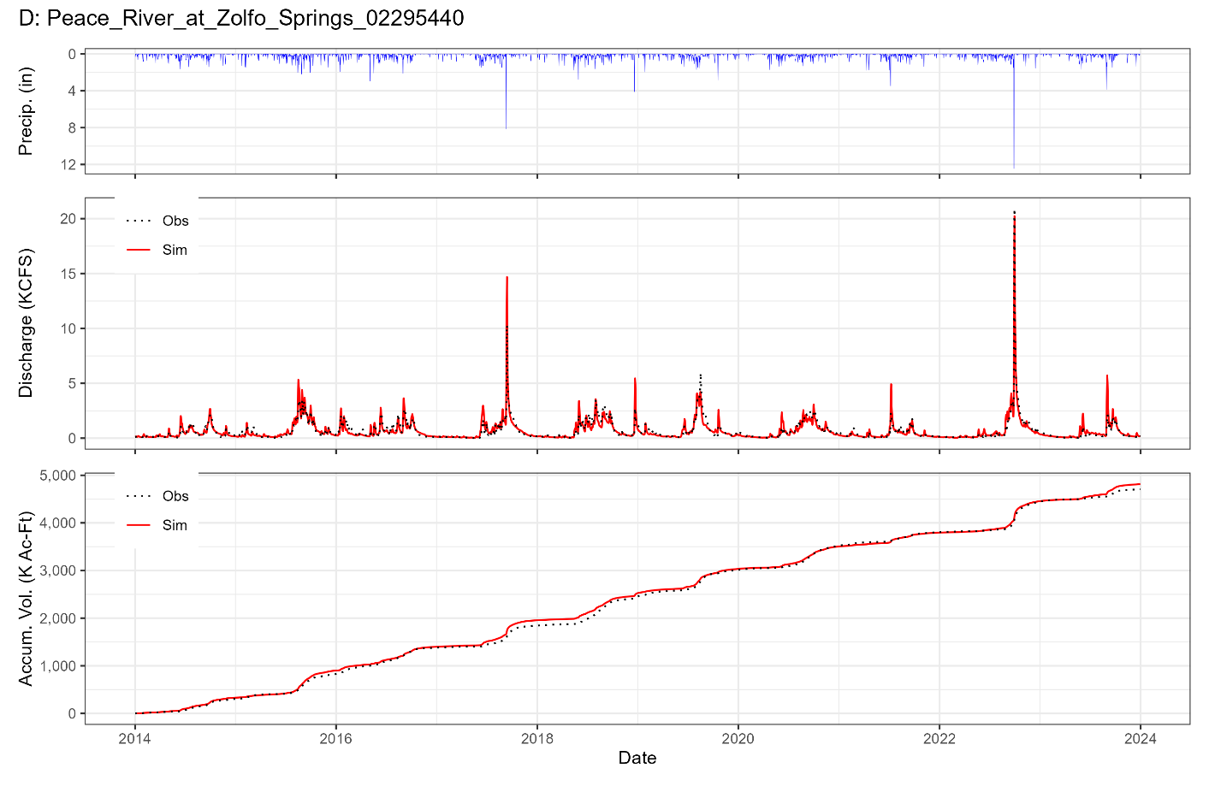
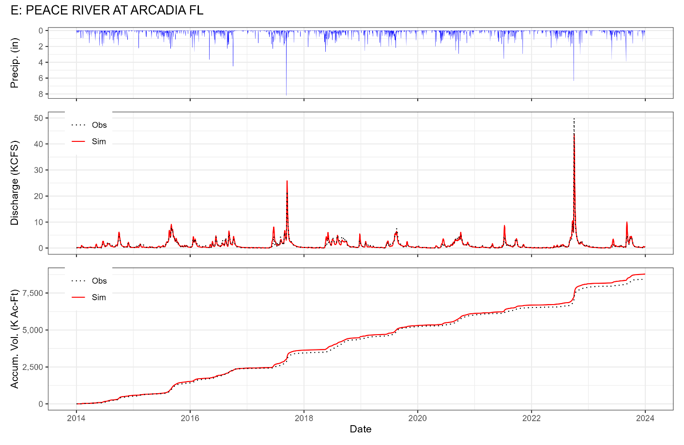
Figure 18. Comparison of measured and simulated flow at five stations along the main stem of the Peace River.

Table 12. Goodness-of-fit statistics over the 2014-2023 calibration period at the five USGS gage locations along the main stem of the Peace River.
Gage Location | RMSE | % bias | NSE | Mod NSE | KGE | KGE non-par | Pears. Corr. | Spear. Rank
Peace River at Bartow (2294650) | 4.58 | 2.5 | 0.79 | 0.59 | 0.77 | 0.84 | 0.90 | 0.87
Peace River at Clear Springs near Bartow (2294775) | 4.44 | -1.9 | 0.80 | 0.60 | 0.74 | 0.83 | 0.91 | 0.88
Peace River at Fort Meade (2294898) | 5.02 | 0.8 | 0.77 | 0.60 | 0.82 | 0.86 | 0.88 | 0.89
Peace River at Zolfo Springs (2295637) | 10.17 | 2.3 | 0.86 | 0.66 | 0.91 | 0.91 | 0.94 | 0.92
Peace River at Arcadia (2296750) | 19.60 | 4.1 | 0.90 | 0.72 | 0.93 | 0.92 | 0.95 | 0.94

Water Quality Calibration

Observed Water Quality Data Collection Locations
Observed water quality data was obtained at 1,542 sampling locations throughout the PRW (Figure 19). Data from these stations were obtained from the publicly available Impaired Waters Rule (IWR) database available from the FDEP, as well as the FDEP Watershed Information Network (WIN). For this project water quality results obtained in lakes in the Upper Peace River basin are not shown, for those results refer to SWET 2022.

Comparison of Observed and Simulated Results
The prediction accuracy of WAM model was evaluated using the observed data at the 1,542 sampling stations in the PRW discussed above. The calibration period used was the same as the hydrologic calibration, i.e., calibration over the 10-year period from the beginning of 2014 through the end of 2023. Note that only a subset of the 1,542 locations had sufficient samples during the calibration period to be used for goodness-of-fit (GoF) calculations. Many of the reaches in the WAM stream network were associated with multiple stations, i.e., a single simulated reach may have multiple stations. In these cases observed results from each sampling station on a reach were combined to allow calibration/validation at those reaches. Observed and simulated results over the calibration period on four WAM reaches distributed along the main stem of the Peace River are shown below, with additional results for the 24-year period shown in the Appendix (Section 10.7.2). These four locations are arranged from the upper end of the Peace River (at State Road 60 at Bartow) to the mouth (the Peace River Estuary Lower Segment) where it discharges into Charlotte Harbor.
Results at these locations show good estimates nutrient concentrations, with bias estimates within ±3.6% with the exception of an underestimate for TP of 19% at the northern end of the Peace River at State Road 60 at Bartow (in Polk County). That particular sampling location is immediately below the confluence with Bear Creek, which discharges the reclaimed and active mining lands to the west. The TP concentrations in Bear Creek are very high, reaching peaks of as much as 34 mg/l at times during the calibration period, and with average concentrations over the past several years of nearly 10 mg/l. Because the creek was not gaged during the calibration period, it was not possible to calculate the observed load during that time and made calibration at this location problematic. The primary contributions to the upper section of the Peace River are the Peace Creek Canal, which drains the north-eastern portion of the basin and contributes approximately 55 – 60% of the flow into the Peace River, and Saddle Creek which drains the north-western portion of the Upper Peace River basin and contributes the remaining 40-45% of the flow. Neither of those tributaries have TP concentrations as high as the Peace River at Bartow, with Peace Creek Canal having an average concentration of 0.15 mg/l and Saddle Creek having an observed average concentration of 0.38 mg/l. This indicates a substantial contribution of TP into the Upper Peace River in the short stretch of the river between the confluence of Saddle and Peace Creeks and the sampling location.
At the water quality sampling locations on the Peace River near Arcadia (in the Joshua Creek basin) (Figure 20c) the estimated values from WAM are close to the observed values, where simulated TN values overestimated the observed values by 3.6% and simulated TP values underestimated observed values by 0.1%. The simulated output values from this reach are used as input at the upstream inflow boundary for the WASP model.

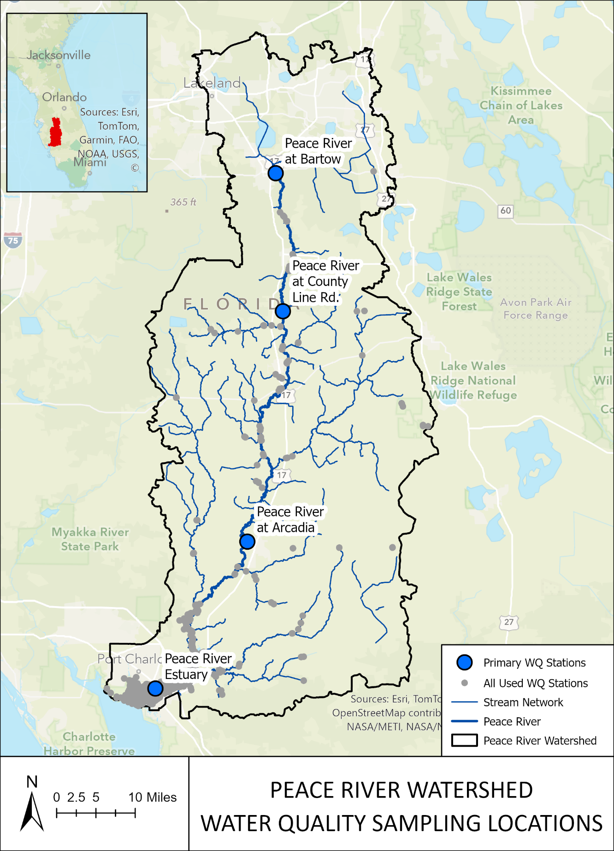
Figure 19. Water quality sampling locations within the model domain used for calibration. Locations denoted by a large blue dot have charts shown below; additional locations shown by gray dots are shown in the Appendix (Section 10.7.2.).
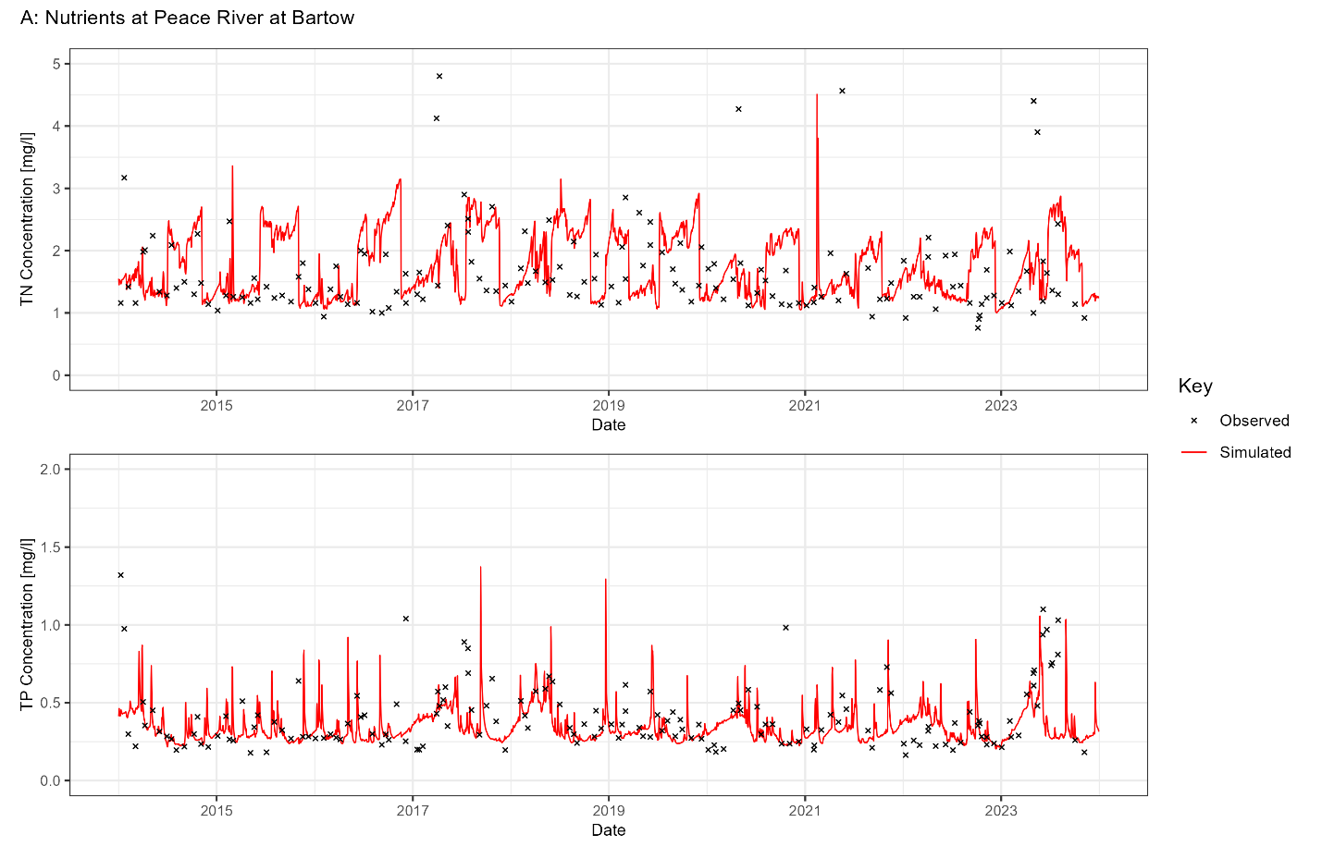
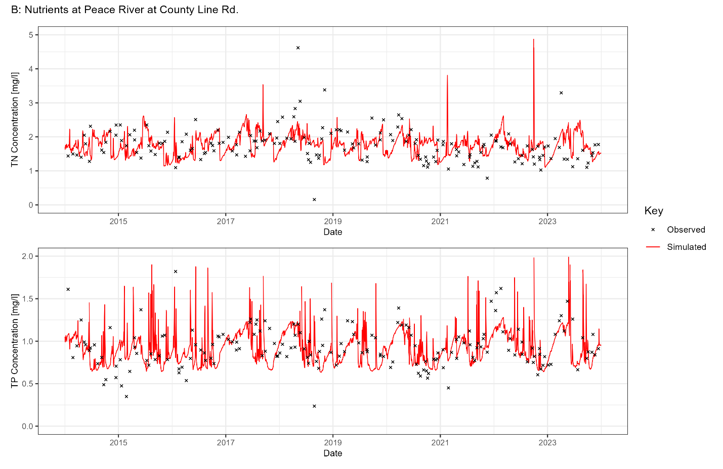
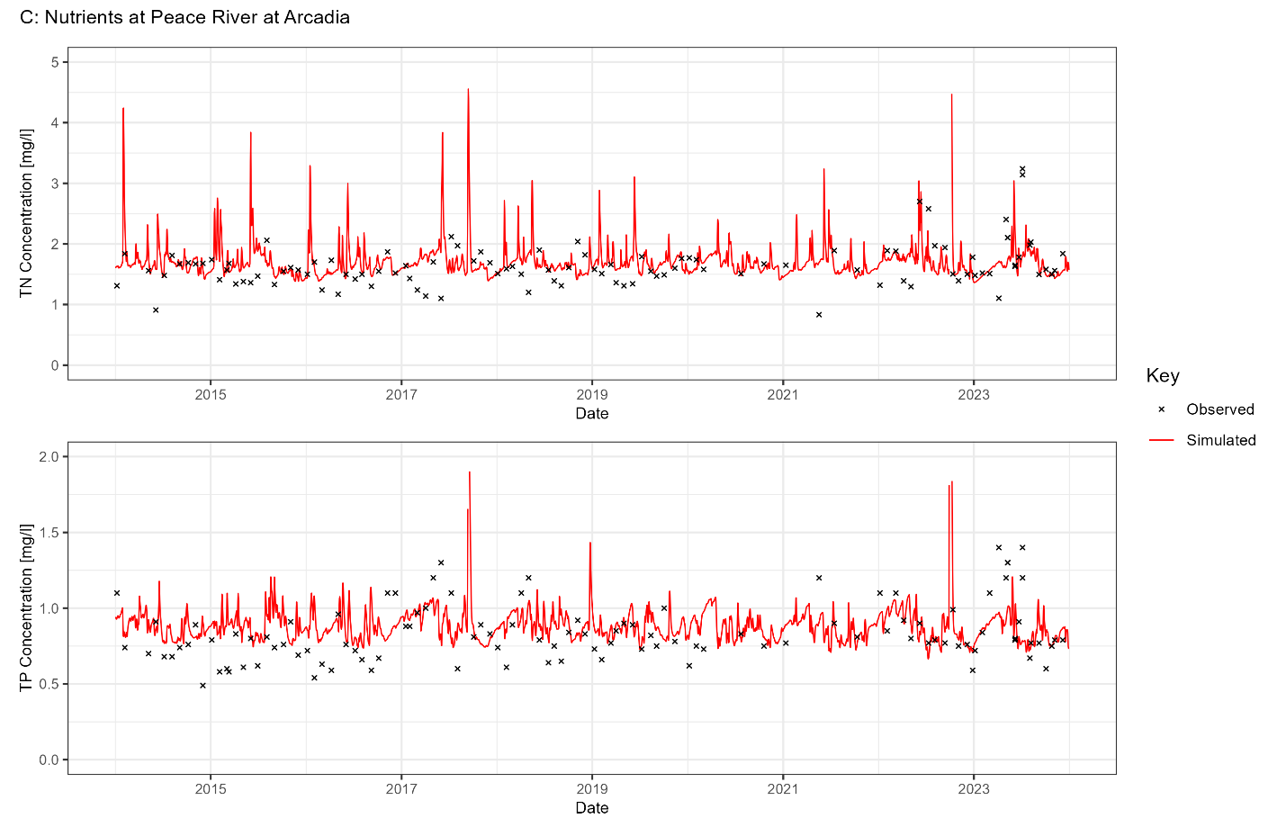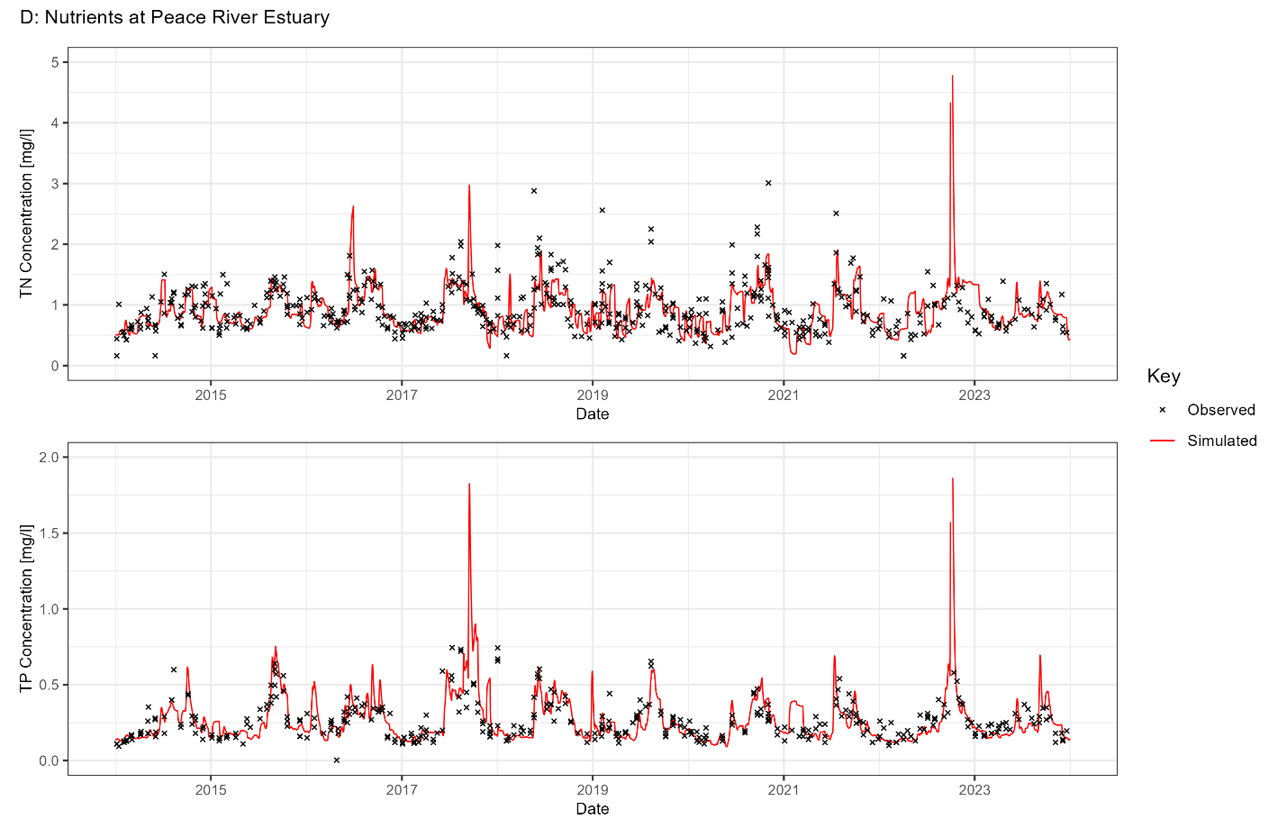
Figure 20. Comparison of measured and simulated TN and TP concentrations at four stations (A – D) along the main stem of the Peace River.
Table 13. Goodness-of-fit statistics over the 2014-2023 period at four water quality sampling locations along the main stem of the Peace River.
Nutrient | Obs Mean | Sim Mean | Num Obs | RMSE | % Bias
Upper Peace River Basin: Peace River above Bowlegs Creek (WAM Reach 802)
TN | 1.75 | 1.80 | 161 | 1.04 | 2.6
TP | 0.42 | 0.34 | 163 | 0.30 | -19
Upper Peace River Basin: Peace River above Payne Creek (WAM Reach 7)
TN | 1.75 | 1.75 | 177 | 0.55 | -0.1
TP | 0.94 | 0.92 | 180 | 0.28 | -1.8
Joshua Creek Basin: Peace River above Joshua Creek (WAM Reach 83)
TN | 1.62 | 1.68 | 109 | 0.42 | 3.6
TP | 0.88 | 0.88 | 109 | 0.60 | -0.1
Charlotte Harbor Basin: Peace River Estuary Lower Segment (WAM Reach 2)
TN | 0.93 | 0.95 | 333 | 0.34 | 2
TP | 0.27 | 0.27 | 206 | 0.11 | 1.6

